**LAPORAN PRAKTIKUM JSON & Ajax**

“Tugas 05 – Menampilkan Cuaca di Jakarta Hari Ini dan Hingga 7 Hari ke Depan*”*



Oleh:

**Nama : Irmawati Pakpahan**

**NPM : 4523210054**

**Kelas : A**

**Tanggal : 8 Oktober 2024**

Dosen:

**Adi Wahyu Pribadi , S.Si., M.Kom**

**S1-Teknik Informatika**

**Fakultas Teknik Universitas Pancasila**

**2023/2024**

**GitHub :** [**https://github.com/IrmawatiPakpahan/Prak-DW/tree/main/pert%206**](https://github.com/IrmawatiPakpahan/Prak-DW/tree/main/pert%206)

**Index.html**

<!DOCTYPE html>

<html lang="en">

<head>

    <meta charset="UTF-8">

    <meta name="viewport" content="width=device-width, initial-scale=1.0">

    <title>Cuaca Jakarta dengan WeatherAPI</title>

    <link rel="stylesheet" href="styles.css">

    <style>

        body {

            font-family: Arial, sans-serif;

            text-align: center;

            margin-top: 50px;

        }

        .weather-info {

            margin-bottom: 20px;

        }

        .forecast {

            display: flex;

            justify-content: center;

            gap: 10px;

        }

        .day {

            padding: 10px;

            border: 1px solid #ccc;

            border-radius: 5px;

            width: 120px;

        }

    </style>

</head>

<body>

    <h1>Cuaca di Jakarta</h1>

    <div id="current-weather" class="weather-info">

        <!-- Cuaca hari ini akan ditampilkan di sini -->

    </div>

    <h2>Ramalan Cuaca 7 Hari ke Depan</h2>

    <div id="weather-forecast" class="forecast">

        <!-- Ramalan cuaca akan ditampilkan di sini -->

    </div>

    <script src="script.js"></script>

</body>

</html>

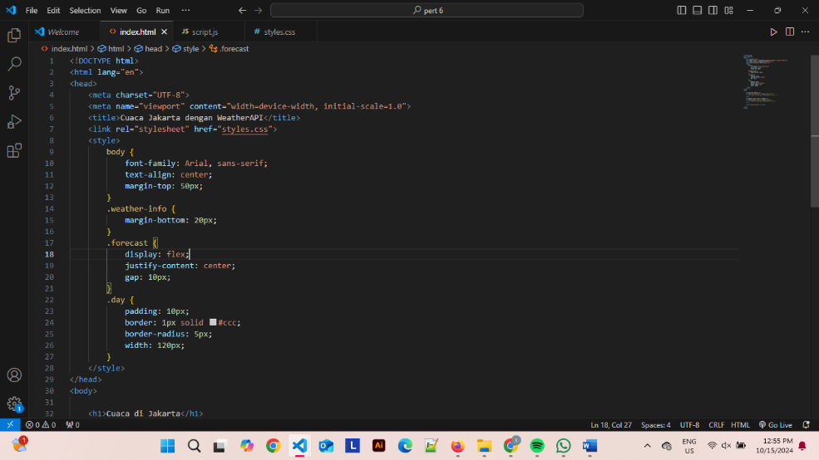

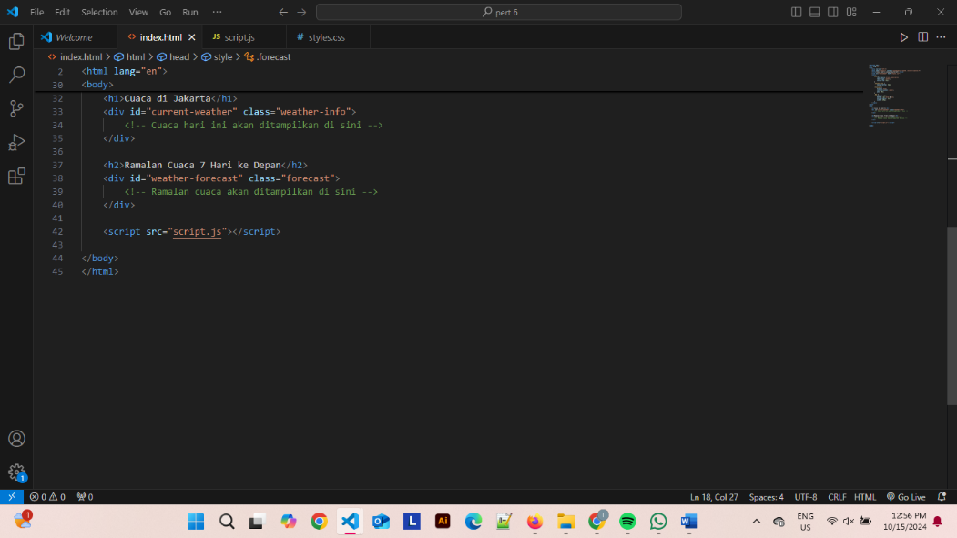

**Script.js**

const apiKey = '93ca149b9f0240eea5c44259241510';  // API key yang Anda dapatkan

const city = 'Jakarta';

// URL untuk API WeatherAPI

const apiURL = `https://api.weatherapi.com/v1/forecast.json?key=${apiKey}&q=${city}&days=7`;

// Fetch data dari WeatherAPI

fetch(apiURL)

    .then(response => {

        if (!response.ok) {

            throw new Error(`HTTP error! status: ${response.status}`);

        }

        return response.json();

    })

    .then(data => {

        console.log(data);

        // Menampilkan cuaca hari ini

        const currentWeatherDiv = document.getElementById('current-weather');

        const currentWeather = data.current;

        currentWeatherDiv.innerHTML = `

            <h2>Cuaca Hari Ini</h2>

            <p>Suhu: ${currentWeather.temp_c}°C</p>

            <p>Deskripsi: ${currentWeather.condition.text}</p>

            <img src="https:${currentWeather.condition.icon}" alt="Ikon Cuaca">

            <p>Kecepatan Angin: ${currentWeather.wind_kph} km/h</p>

            <p>Kelembapan: ${currentWeather.humidity}%</p>

        `;

        // Menampilkan ramalan cuaca 7 hari ke depan

        const forecastDiv = document.getElementById('weather-forecast');

        let forecastHTML = '';

        data.forecast.forecastday.forEach((day) => {

            const date = new Date(day.date);

            const options = { weekday: 'long', year: 'numeric', month: 'long', day: 'numeric' };

            const formattedDate = date.toLocaleDateString('id-ID', options);

            forecastHTML += `

                <div class="day">

                    <h4>${formattedDate}</h4>

                    <img src="https:${day.day.condition.icon}" alt="Ikon Cuaca">

                    <p>Suhu Siang: ${day.day.maxtemp_c}°C</p>

                    <p>Suhu Malam: ${day.day.mintemp_c}°C</p>

                    <p>Cuaca: ${day.day.condition.text}</p>

                </div>

            `;

        });

        forecastDiv.innerHTML = forecastHTML;

    })

    .catch(error => {

        console.error('Error:', error);

        document.getElementById('current-weather').innerHTML = '<p>Terjadi kesalahan saat mengambil data cuaca.</p>';

        document.getElementById('weather-forecast').innerHTML = '<p>Ramalan cuaca tidak dapat ditampilkan.</p>';

    });

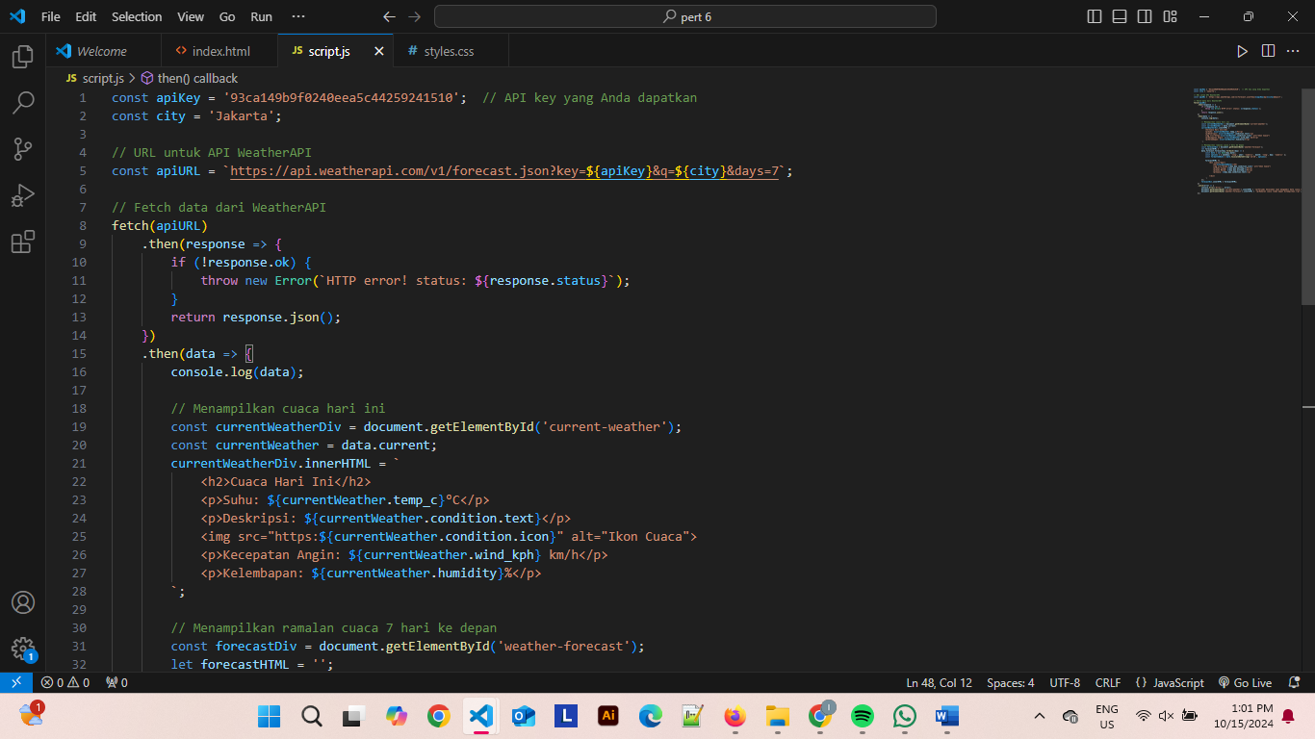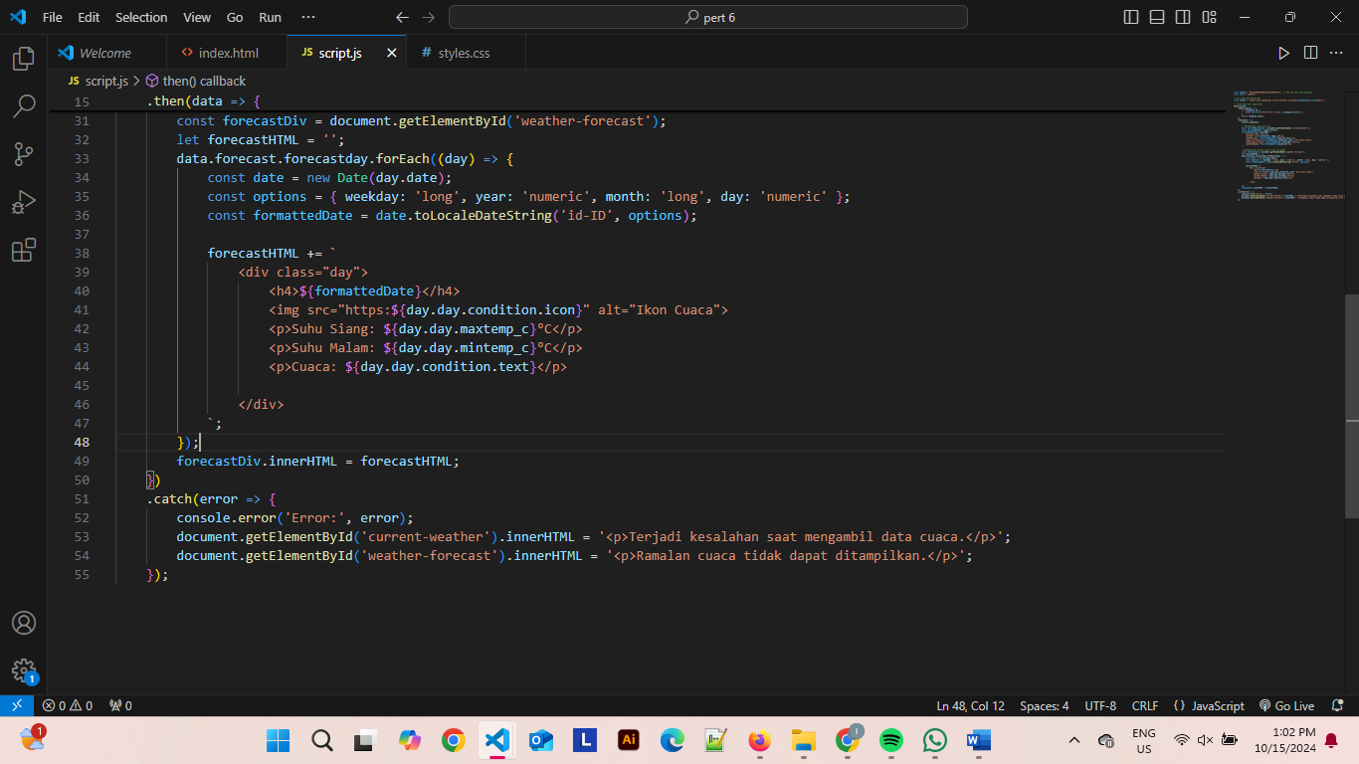

**Styles.css**

/* Import Google Fonts */

@import url('https://fonts.googleapis.com/css2?family=Roboto:wght@400;700&family=Open+Sans:wght@400;600&display=swap');

body {

    font-family: 'Poppins', Arial, sans-serif;

    background: linear-gradient(135deg, #551a99, #3c1fa3);

    color: #333;

    text-align: center;

    margin: 0;

    padding: 20px;

}

h1 {

    background-color: #8f25d6;

    color: white;

    padding: 15px;

    text-align: center;

    margin: 0;

}

h2 {

    margin: 20px;

    font-size: 24px;

    color: #4b89bb;

    text-align: center;

}

.weather-info {

    background: rgba(255, 255, 255, 0.8);

    border-radius: 10px;

    padding: 20px;

    box-shadow: 0 4px 8px rgba(0, 0, 0, 0.2);

    margin-bottom: 30px;

}

.forecast {

    display: flex;

    justify-content: center;

    gap: 15px;

    flex-wrap: wrap;

}

.day {

    background: #fff;

    border: 2px solid #ccc;

    border-radius: 8px;

    padding: 15px;

    width: 130px;

    box-shadow: 0 2px 6px rgba(0, 0, 0, 0.1);

    transition: transform 0.3s ease, box-shadow 0.3s ease;

}

.day:hover {

    transform: translateY(-10px);

    box-shadow: 0 8px 16px rgba(0, 0, 0, 0.3);

}

.day h3 {

    font-size: 1.2rem;

    margin-bottom: 10px;

    color: #333;

}

.day p {

    font-size: 0.9rem;

    color: #666;

}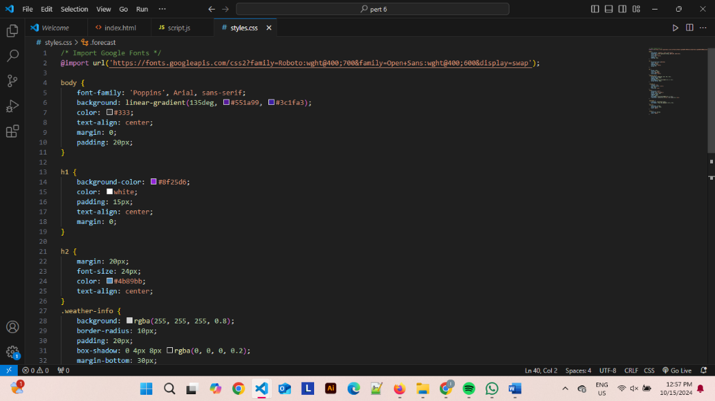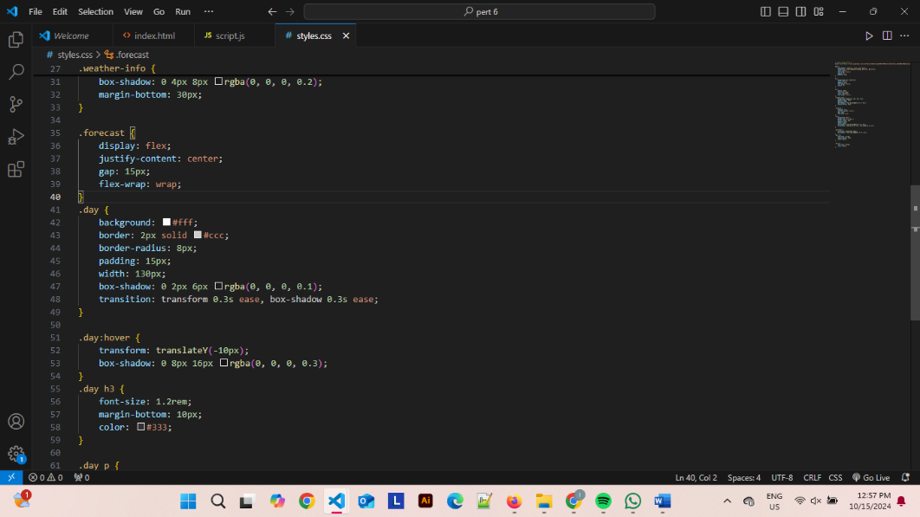

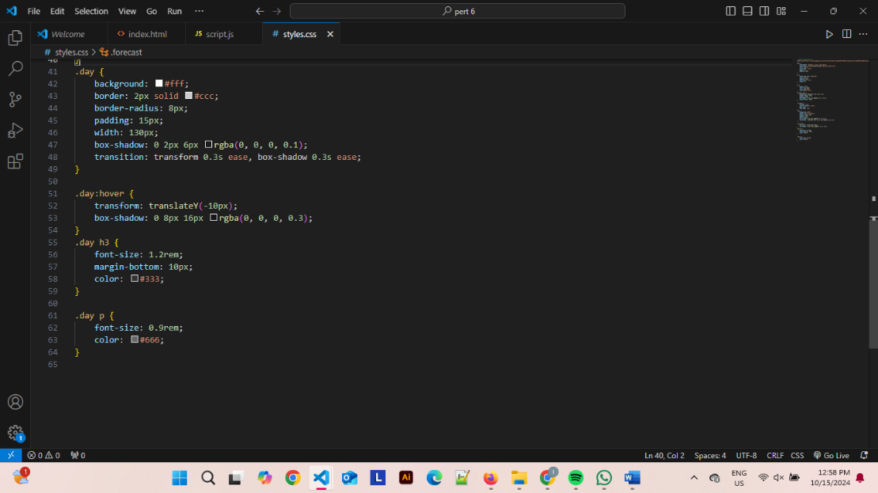

**HASIL**

